Multiple Access Protocols

1. If there is a dedicated link between the sender and the receiver then data link control later is sufficient, however if there is no dedicated link present then multiple stations can access the channel simultaneously.
2. Hence multiple access protocols are required to decrease **collison** and avoid crosstalk.
3. 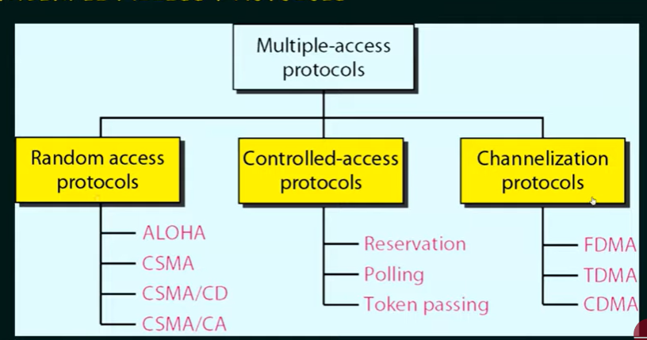

Random access protocols

1. In this, all stations have the same superiority, that is no station has more priority than another station. Any station can send data depending on medium’s state (idle or busy)
2. In a random access method, each station has the right to the medium without being controlled by any other station.
3. If more than one station tries to send, there is an access conflict (COLLISION) and the frames will be either destroyed or modified.
4. To avoid conflict, each station follows a procedure:
   1. When can the station access the medium?
   2. What can the station do if the medium is busy?
   3. How can the station determine the success or failure of the transmission?
   4. What can the station do if there is an access conflict?

Control Access Protocols

1. In controlled access the stations consult one another to find which station has the right to send.
2. A station cannot send unless it has been authorized by other stations.

Channelization Protocols

1. Channelization is a multiple-access method in which the available bandwidth of a link is shared in time, frequency, or through code between different station.